**Title**

Live plotting of data coming from sound senor using MATLAB

**Components**

* Arduino MEGA
* 3 sound sensors KY 038
* bread board
* 2 XBee

**Procedure**

Connect three sound sensors into Arduino. And then using xctu to program XBee one as coordinator device and other end device. End device would give the live data to end device which would throw the data to coordinator device then using MATLAB plots are obtained of live data.

**Code**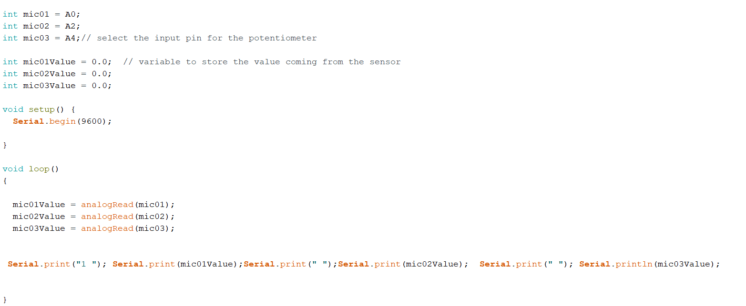

**Application**

* this idea can be Implemented in acoustics radar
* idea can be used for security purposes